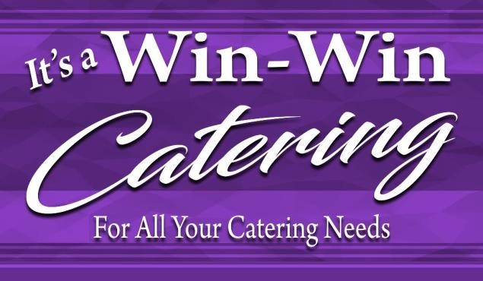 3555 Dorchester Road North Charleston, SC 29407

It’s a Win-Win Catering, LLC is a family of professionals with personal values. The daily interactions our customers, clients, and suppliers engage in are guided by our goal to deliver service without compromise. Our values are simple, but essential to our success.
Our Mission
Everyone in It’s a Win-Win Catering, LLC is committed to consistently delivering superior service in the most efficient way, for the shared benefit of our customers and associates.
Our Vision
To be a world-class provider of contract foodservice and support services, renowned for our great people, our great service, and our great results.
Our Guiding Principles
- Safety, Health and Environment First– Never compromise on the health and safety of our customers and our people, and manage responsibly the impact that our business has on the environment.
- Delivering for Clients and Consumers– Earn the continued loyalty of our customers by consistently demonstrating why we are the first choice for quality, service, value, and innovation.
- Developing our People and Valuing Diversity – Recognize the diversity and contribution of our people. We create a work environment that is challenging and provides the opportunities and support for everyone to develop, learn, and succeed.
- Profitable Growth – Deliver value through disciplined, sustainable growth, underpinned by strong governance that contributes to and leverages the benefits of our global view.
- Constant Focus on Performance and Efficiency – Deliver the highest quality and performance, whilst relentlessly driving to be the lowest cost, most efficient provider.
Our Values
- Openness, Trust and Integrity – We set the highest ethical and professional standards at all times. We want all our relationships to be based on honesty, respect, fairness, and a commitment to open dialogue and transparency.
- Passion for Quality – We are passionate about delivering superior food and service and take pride in achieving this. We look to replicate success, learn from mistakes, and develop the ideas, innovations, and practices that will help us improve and lead our market.
- Win Through Teamwork – We encourage individual ownership, but work as a team. We value the expertise, individuality, and contribution of all colleagues, working in support of each other and readily sharing good practice, in pursuit of shared goals.
- Responsibility – We take responsibility for our actions, individually and as a Group. Every day, everywhere, we look to make a positive contribution to the health and wellbeing of our customers, the communities we work in, and the world we live in.
- Can-do – We take a positive and commercially aware “can-do” approach to the opportunities and challenges we face.

